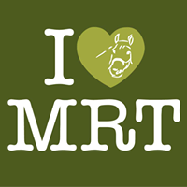
FIRE SAFETY TRAINING
Introduction for Volunteers
It is the duty of management bodies of Muirfield Riding Therapy to provide appropriate training in all aspects of the running of the charity.
Fire Training is vital to the safety of
- Riders
- Volunteers
- Families & Carers
- Equines
All you need to know should be contained in the attached documents below but if you have any questions or concerns please address them to the Operating Group or Board of Directors through your Session Mentor.
As part of the new Volunteer's Training Schedule, the attached will be presented but it is important for trained Volunteer's to refresh their knowledge every 6 months.
The Fire Safety Training presentation is on the desk top in the 1st Office, clearly labelled and also on the website so that you can view from home.
Fire Drills will be carried out from time to time and should be conducted as if it is a real fire incident.
We thank you for your attention to this important part of your training.
Susan Law (Chairman)
17/1/17

